Decision Trees
Practical work n° 9
toumi abderahmane, damine saad
11 november 2019

keywords : machine learning, python , data sets,sklearn, pandas, decision trees,

Abstract
A Decision Tree is a simple representation for classifying examples. It is a Supervised Machine Learning where the data is continuously split according to a certain parameter

Methods and Materials

Materials:

software :
- MySQL dbms
- Navicat for MySql
2.hardware :
- processeur : i3 VI
- ram : 8mb
-hard disk : 125 gb

Results
In this work we have the data set “Train_v2” which represent a financial info about each interviewee
So we are trying to classify this interviewee our output is “bank_account “ define whether this interviewee have or doesn’t have a bank account , the input is the rest of columns except “unique_id”

First lets use pandas to read our Train_v2 .csv and see what we have , we can get info and shape too

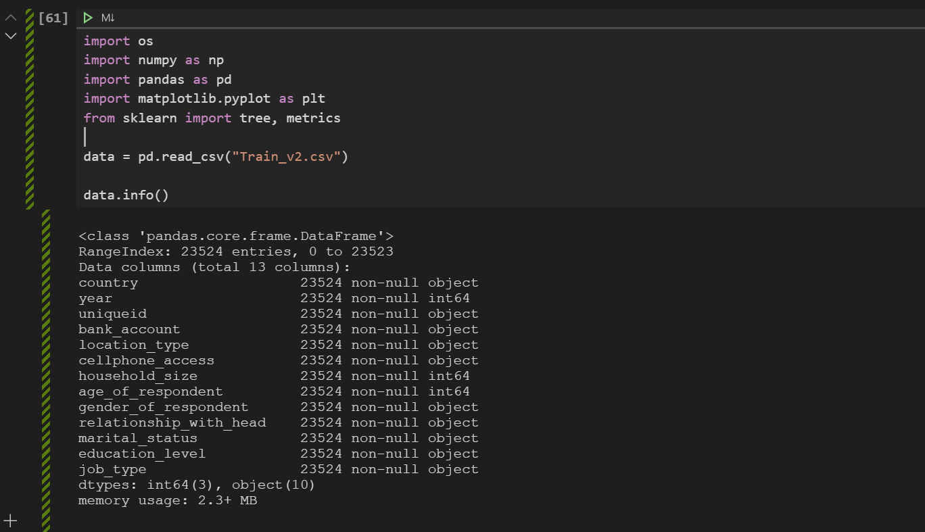Figure 1: read csv and get some info

Now lets drop the unique id and see how the data look like again
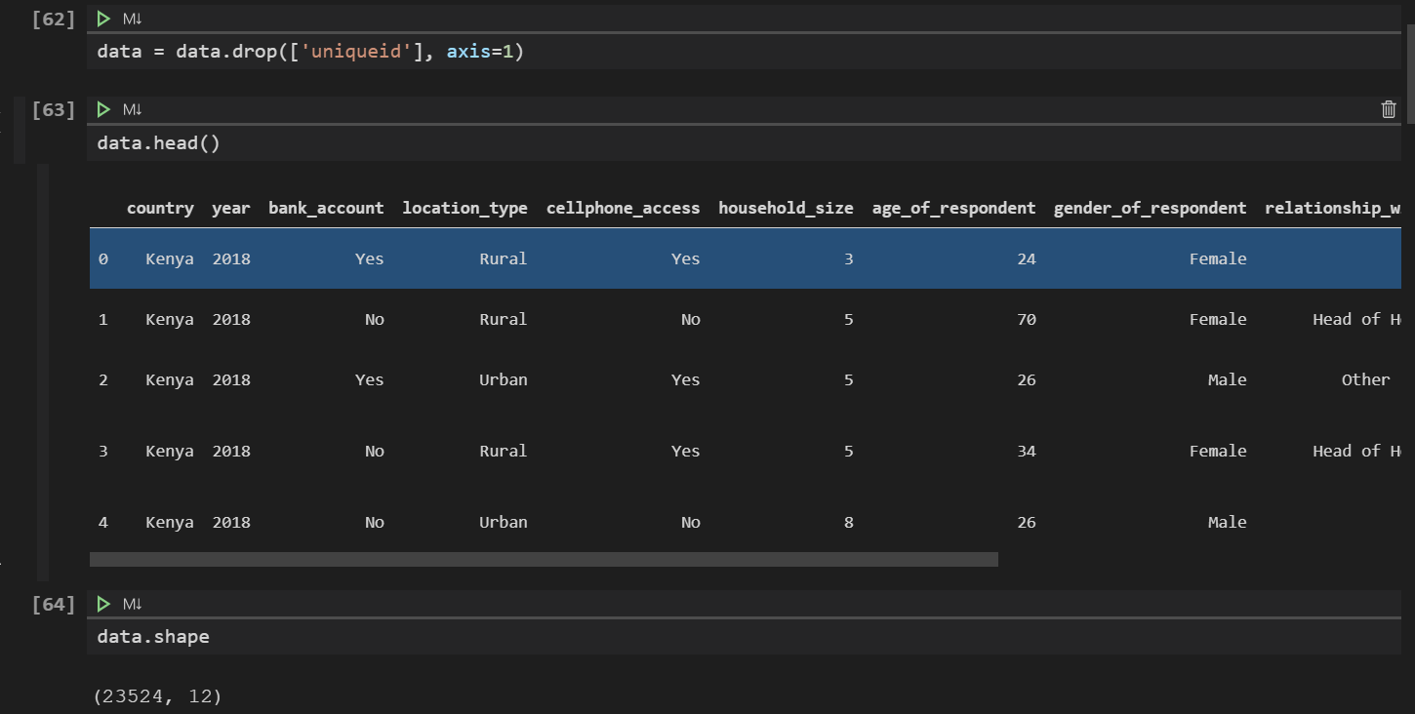Figure 2: drop unique_id and display the head and shape of the data
Now we are ready to convert our columns to a unique numeric types using factorize
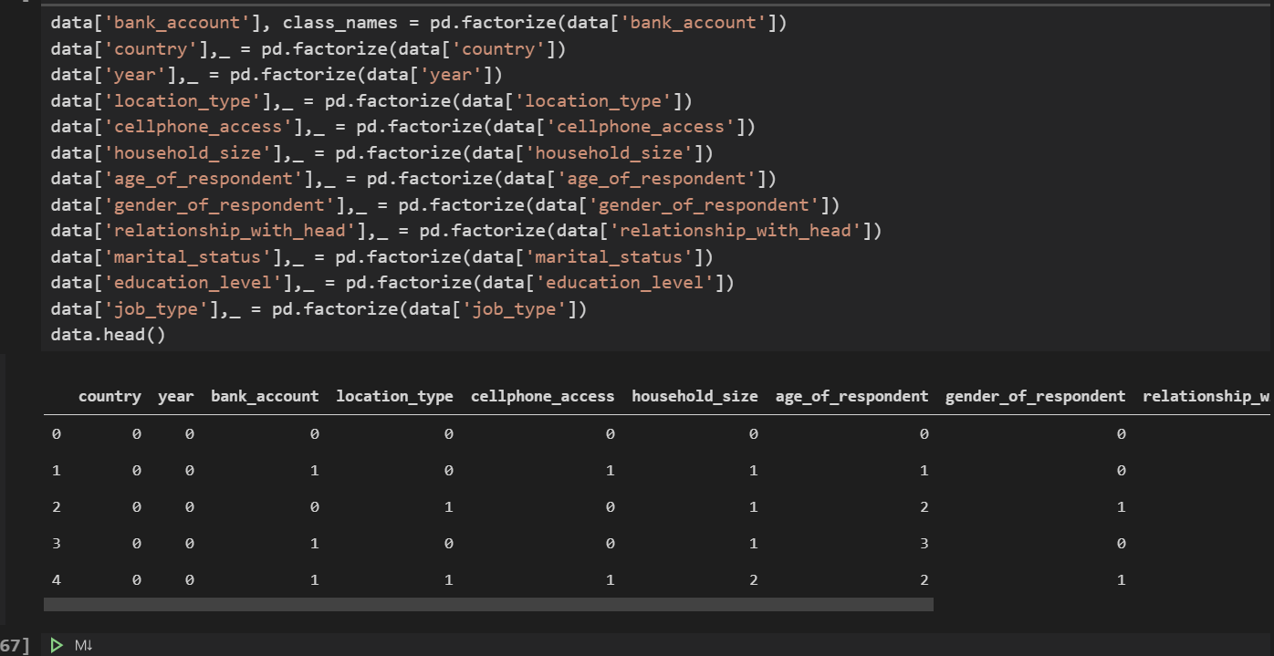Figure 3: Convert columns to numeric types

Separate data into an input ‘x’ and output ‘y’
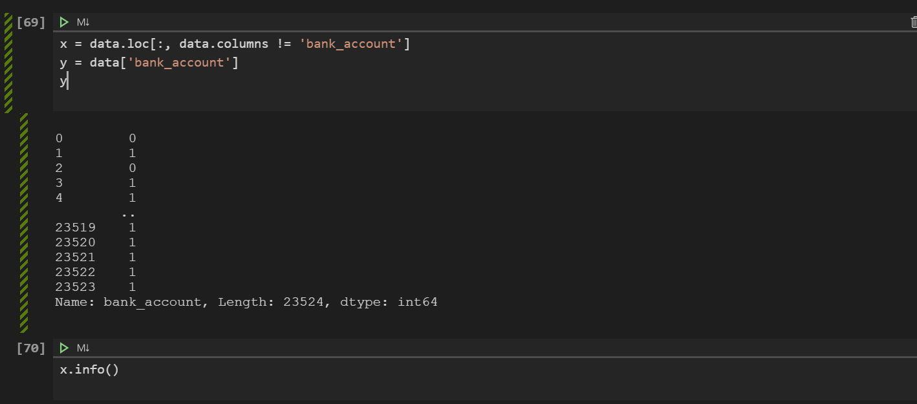Figure 4: input is x and the output is y
Now we are ready to split the data into training and testing , and start the training and the prediction phase after that we will calculate the miss classified samples and the accuracy
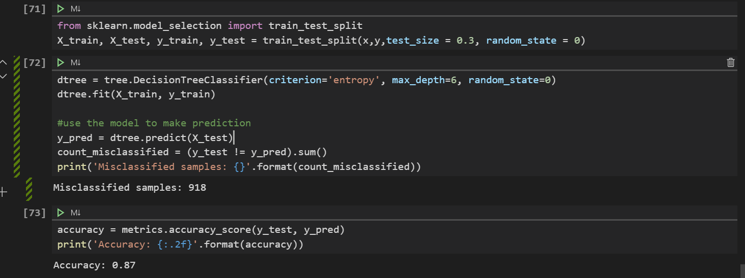Figure 5: Train, Split, Predict

Display the tree using “graphviz”
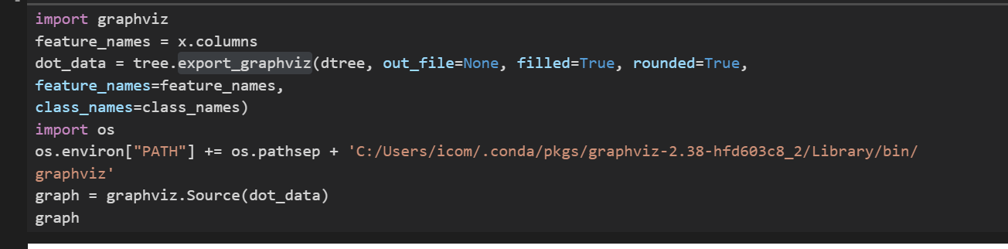Figure 6: code to visualize decision tree using graphviz
Visualissation of the tree is in this file below “Source.gv”

Conclusion
The accuracy was 87% with 918 miss classified samples this was a good result

